A000-BMAC-Iconography

Early Old Elamite seals of the Sukkalmah (ca. 20th- 19th centuries b.c.e.). The cylinder seals of the Sukkalmah and their officials were divided by Ursula Seidl (1990) into three chronologically sequential groups. She has used the dates available for the seal impressions and cylinders of the period, which are a valuable guide for further research.  
  
Here a further division is suggested for the earliest group of cylinders, in which a western and an eastern group can be recognized. In the western group the placing of the figures conforms to the Old Babylonian presentation of a worshiper to a deity, while the attire of the figures is distinctively Elamite, especially the hair style with the hair projecting over the forehead. In the rare representations of deities with horned crowns the horns have an S shape turning outward at the ends, unlike the Babylonian horns, which turn inward at the top. The long garments show a narrow waist and a bell- like extension at the bottom. Most characteristic is the gesture of the hands, which are extended toward the deity or the ruler figure. The hands appear to be cupped to receive the bounty occasionally dispensed by the deity or the ruler in the form of streams of what was probably water ([Plate XLIII](http://www.iranicaonline.org/uploads/files/Cylinder_Seals/v6f5a019_f8_300.jpg)/6; Porada, 1990, pl. II/16).



Seidl suggests that the gesture also implies communication between god and worshiper and considers the meaning of the gesture to be one of prayer (1990, p. 132).  
  
The eastern group is distinguished by the appearance of ladies in “crinolines.” Cylinder and stamp seals with this motif were found at Tell Malyan (Tall-e Malīān), ancient [Anshan](http://www.iranicaonline.org/articles/anshan-elamite-region). Several of the cylinders show the lady seated under a vine. She wears a voluminous garment apparently made of a flounced material in several tiers. The male figure on the cylinder of the wife of Ebarat II ([Plate XLIII](http://www.iranicaonline.org/uploads/files/Cylinder_Seals/v6f5a019_f8_300.jpg)/5; Lambert, 1979) wears a turban-like headgear and holds a flower, a motif for which there is no parallel in the west. Nor do women appear prominently in Old Babylonian ritual scenes, as they do in those of the eastern group of Sukkalmah-period cylinders of Persia.



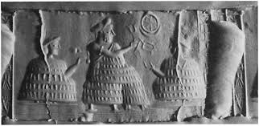

After W. G. Lambert’s publication of the seal in [Plate XLIII](http://www.iranicaonline.org/uploads/files/Cylinder_Seals/v6f5a019_f8_300.jpg)/5, several cylinders and sealings of related style were published (Amiet, 1980a; Steve, 1989; Porada, 1990), but only one poorly reproduced cylinder seal and one stamp seal ([Plate XLIII](http://www.iranicaonline.org/uploads/files/Cylinder_Seals/v6f5a019_f8_300.jpg)/7; Sumner, 1974, p. 172 fig. 12/i) have so far been published from the several representations of the lady under the vine found in the controlled excavation of Tell Malyan.

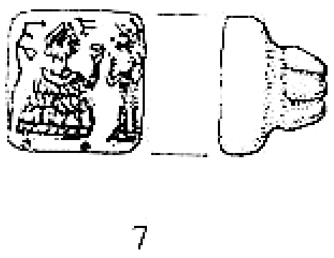



http://dare.ht.lu.se/tiles/imperium/9/331/211.png

These seal designs will feature prominently, however, in Pitmann’s forthcoming publication of the seals of the Kaftari (Kaftarī) period from Malyan. They indicate the region in which the eastern group originated. One of the seal designs showing a ruler figure dispens ing streams to a seated female was made with a cylin der belonging to an official of the Sukkalmah Pala ishshan, recently dated in the middle of the 20th century b.c.e. (Vallat, 1989; Pétréquin)